What is a Computer Network?

* **Computer Network** is a group of computers connected with each other through wires, optical fibres or optical links so that various devices can interact with each other through a network.
* The aim of the computer network is the sharing of resources among various devices.

# Features Of Computer network

### **Communication speed**

Network provides us to communicate over the network in a fast and efficient manner. For example, we can do video conferencing, email messaging, etc. over the internet. Therefore, the computer network is a great way to share our knowledge and ideas.

### **File sharing**

File sharing is one of the major advantage of the computer network. Computer network provides us to share the files with each other.

### **Back up and Roll back is easy**

Since the files are stored in the main server which is centrally located. Therefore, it is easy to take the back up from the main server.

### **Software and Hardware sharing**

We can install the applications on the main server, therefore, the user can access the applications centrally. So, we do not need to install the software on every machine. Similarly, hardware can also be shared.

### **Security**

Network allows the security by ensuring that the user has the right to access the certain files and applications.

### **Scalability**

Scalability means that we can add the new components on the network. Network must be scalable so that we can extend the network by adding new devices. But, it decreases the speed of the connection and data of the transmission speed also decreases, this increases the chances of error occurring. This problem can be overcome by using the routing or switching devices.

### **Reliability**

Computer network can use the alternative source for the data communication in case of any hardware failure.

# Computer Network Architecture

Computer Network Architecture is defined as the physical and logical design of the software, hardware, protocols, and media of the transmission of data. Simply we can say that how computers are organized and how tasks are allocated to the computer.

**The two types of network architectures are used:**

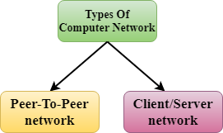

* Peer-To-Peer network
* Client/Server network

## **Peer-To-Peer network**

* Peer-To-Peer network is a network in which all the computers are linked together with equal privilege and responsibilities for processing the data.
* Peer-To-Peer network is useful for small environments, usually up to 10 computers.
* Peer-To-Peer network has no dedicated server.
* Special permissions are assigned to each computer for sharing the resources, but this can lead to a problem if the computer with the resource is down.

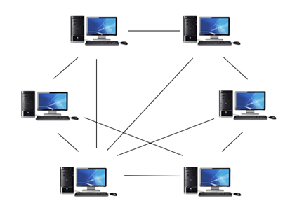

### **Advantages Of Peer-To-Peer Network:**

* It is less costly as it does not contain any dedicated server.
* If one computer stops working but, other computers will not stop working.
* It is easy to set up and maintain as each computer manages itself.

### **Disadvantages Of Peer-To-Peer Network:**

* In the case of Peer-To-Peer network, it does not contain the centralized system . Therefore, it cannot back up the data as the data is different in different locations.
* It has a security issue as the device is managed itself.

## **Client/Server Network**

* Client/Server network is a network model designed for the end users called clients, to access the resources such as songs, video, etc. from a central computer known as Server.
* The central controller is known as a **server** while all other computers in the network are called **clients**.
* A server performs all the major operations such as security and network management.
* A server is responsible for managing all the resources such as files, directories, printer, etc.
* All the clients communicate with each other through a server. For example, if client1 wants to send some data to client 2, then it first sends the request to the server for the permission. The server sends the response to the client 1 to initiate its communication with the client 2.

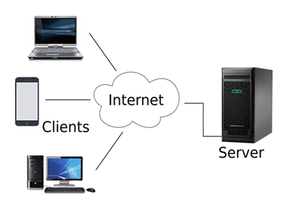

### **Advantages Of Client/Server network:**

* A Client/Server network contains the centralized system. Therefore we can back up the data easily.
* A Client/Server network has a dedicated server that improves the overall performance of the whole system.
* Security is better in Client/Server network as a single server administers the shared resources.
* It also increases the speed of the sharing resources.

### **Disadvantages Of Client/Server network:**

* Client/Server network is expensive as it requires the server with large memory.
* A server has a Network Operating System(NOS) to provide the resources to the clients, but the cost of NOS is very high.
* It requires a dedicated network administrator to manage all the resources.

# Computer Network Types

## **LAN(Local Area Network)**

* Local Area Network is a group of computers connected to each other in a small area such as building, office.
* LAN is used for connecting two or more personal computers through a communication medium such as twisted pair, coaxial cable, etc.
* It is less costly as it is built with inexpensive hardware such as hubs, network adapters, and ethernet cables.
* The data is transferred at an extremely faster rate in Local Area Network.
* Local Area Network provides higher security.

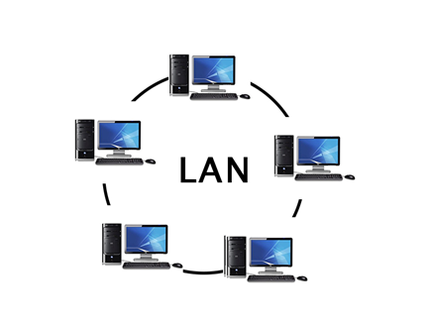

## **PAN(Personal Area Network)**

* Personal Area Network is a network arranged within an individual person, typically within a range of 10 meters.
* Personal Area Network is used for connecting the computer devices of personal use is known as Personal Area Network.
* covers an area of **30 feet**.
* Personal computer devices that are used to develop the personal area network are the laptop, mobile phones, media player and play stations.

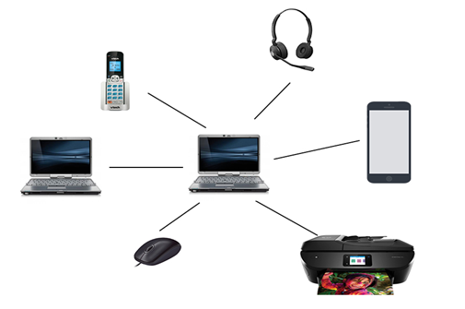

**There are two types of Personal Area Network:**

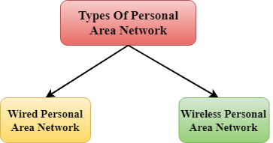

* Wired Personal Area Network
* Wireless Personal Area Network

**Wireless Personal Area Network:** Wireless Personal Area Network is developed by simply using wireless technologies such as WiFi, Bluetooth. It is a low range network.

**Wired Personal Area Network:** Wired Personal Area Network is created by using the USB.

## **MAN(Metropolitan Area Network)**

* A metropolitan area network is a network that covers a larger geographic area by interconnecting a different LAN to form a larger network.
* Government agencies use MAN to connect to the citizens and private industries.
* In MAN, various LANs are connected to each other through a telephone exchange line.
* The most widely used protocols in MAN are RS-232, Frame Relay, ATM, ISDN, OC-3, ADSL, etc.
* It has a higher range than Local Area Network(LAN).

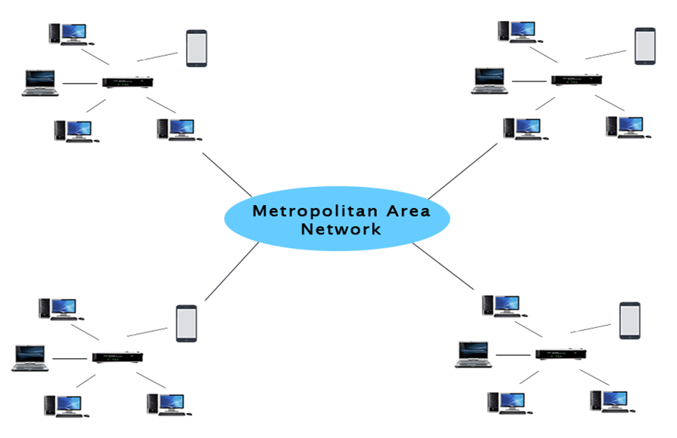

### **Uses Of Metropolitan Area Network:**

* MAN is used in communication between the banks in a city.
* It can be used in an Airline Reservation.
* It can be used in a college within a city.
* It can also be used for communication in the military.

## **WAN(Wide Area Network)**

* A Wide Area Network is a network that extends over a large geographical area such as states or countries.
* A Wide Area Network is quite bigger network than the LAN.
* A Wide Area Network is not limited to a single location, but it spans over a large geographical area through a telephone line, fibre optic cable or satellite links.
* The internet is one of the biggest WAN in the world.
* A Wide Area Network is widely used in the field of Business, government, and education.

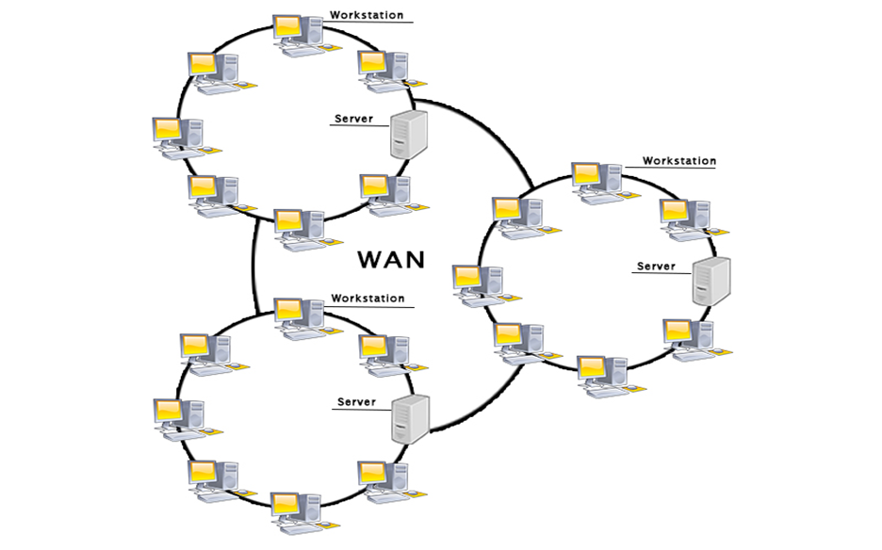

## **Internetwork**

* An internetwork is defined as two or more computer network LANs or WAN or computer network segments are connected using devices, and they are configured by a local addressing scheme. This process is known as **internetworking**.
* An interconnection between public, private, commercial, industrial, or government computer networks can also be defined as **internetworking**.
* An internetworking uses the **internet protocol**.
* The reference model used for internetworking is **Open System Interconnection(OSI)**.

## **Types Of Internetwork:**

1. **Extranet:** An extranet is a communication network based on the internet protocol such as **Transmission Control protocol** and **internet protocol**. It is used for information sharing. The access to the extranet is restricted to only those users who have login credentials. An extranet is the lowest level of internetworking. It can be categorized as **MAN**, **WAN** or other computer networks. An extranet cannot have a single **LAN**, atleast it must have one connection to the external network.

2. **Intranet:** An intranet is a private network based on the internet protocol such as **Transmission Control protocol** and **internet protocol**. An intranet belongs to an organization which is only accessible by the **organization's employee** or members. The main aim of the intranet is to share the information and resources among the organization employees. An intranet provides the facility to work in groups and for teleconferences.

## **Intranet advantages:**

* **Communication:** It provides a cheap and easy communication. An employee of the organization can communicate with another employee through email, chat.
* **Time-saving:** Information on the intranet is shared in real time, so it is time-saving.
* **Collaboration:** Collaboration is one of the most important advantage of the intranet. The information is distributed among the employees of the organization and can only be accessed by the authorized user.
* **Platform independency:** It is a neutral architecture as the computer can be connected to another device with different architecture.
* **Cost effective:** People can see the data and documents by using the browser and distributes the duplicate copies over the intranet. This leads to a reduction in the cost.

# What is Topology?

Topology defines the structure of the network of how all the components are interconnected to each other. There are two types of topology: physical and logical topology.

Physical topology is the geometric representation of all the nodes in a network.

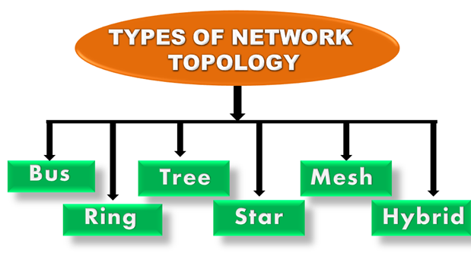

## **Bus Topology**

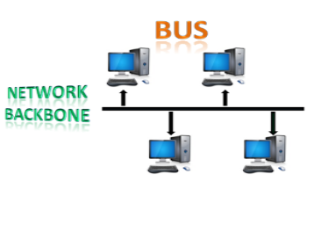

* The bus topology is designed in such a way that all the stations are connected through a single cable known as a backbone cable.
* Each node is either connected to the backbone cable by drop cable or directly connected to the backbone cable.
* When a node wants to send a message over the network, it puts a message over the network. All the stations available in the network will receive the message whether it has been addressed or not.
* The bus topology is mainly used in 802.3 (ethernet) and 802.4 standard networks.
* The configuration of a bus topology is quite simpler as compared to other topologies.
* The backbone cable is considered as a **"single lane"** through which the message is broadcast to all the stations.
* The most common access method of the bus topologies is **CSMA** (Carrier Sense Multiple Access).

### **Advantages of Bus topology:**

* **Low-cost cable:** In bus topology, nodes are directly connected to the cable without passing through a hub. Therefore, the initial cost of installation is low.
* **Moderate data speeds:** Coaxial or twisted pair cables are mainly used in bus-based networks that support upto 10 Mbps.
* **Familiar technology:** Bus topology is a familiar technology as the installation and troubleshooting techniques are well known, and hardware components are easily available.
* **Limited failure:** A failure in one node will not have any effect on other nodes.

### **Disadvantages of Bus topology:**

* **Extensive cabling:** A bus topology is quite simpler, but still it requires a lot of cabling.
* **Difficult troubleshooting:** It requires specialized test equipment to determine the cable faults. If any fault occurs in the cable, then it would disrupt the communication for all the nodes.
* **Signal interference:** If two nodes send the messages simultaneously, then the signals of both the nodes collide with each other.
* **Reconfiguration difficult:** Adding new devices to the network would slow down the network.
* **Attenuation:** Attenuation is a loss of signal leads to communication issues. Repeaters are used to regenerate the signal.

## **Ring Topology**

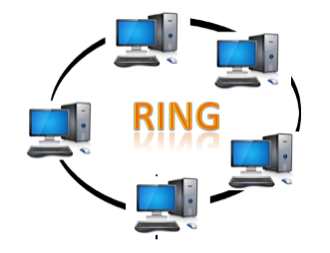

* Ring topology is like a bus topology, but with connected ends.
* The node that receives the message from the previous computer will retransmit to the next node.
* The data flows in one direction, i.e., it is unidirectional.
* The data flows in a single loop continuously known as an endless loop.
* It has no terminated ends, i.e., each node is connected to other node and having no termination point.
* The data in a ring topology flow in a clockwise direction.
* The most common access method of the ring topology is **token passing**.
  + **Token passing:** It is a network access method in which token is passed from one node to another node.
  + **Token:** It is a frame that circulates around the network.

### **Working of Token passing**

* A token moves around the network, and it is passed from computer to computer until it reaches the destination.
* The sender modifies the token by putting the address along with the data.
* The data is passed from one device to another device until the destination address matches. Once the token received by the destination device, then it sends the acknowledgment to the sender.
* In a ring topology, a token is used as a carrier.

### **Advantages of Ring topology:**

* **Network Management:** Faulty devices can be removed from the network without bringing the network down.
* **Product availability:** Many hardware and software tools for network operation and monitoring are available.
* **Cost:** Twisted pair cabling is inexpensive and easily available. Therefore, the installation cost is very low.
* **Reliable:** It is a more reliable network because the communication system is not dependent on the single host computer.

### **Disadvantages of Ring topology:**

* **Difficult troubleshooting:** It requires specialized test equipment to determine the cable faults. If any fault occurs in the cable, then it would disrupt the communication for all the nodes.
* **Failure:** The breakdown in one station leads to the failure of the overall network.
* **Reconfiguration difficult:** Adding new devices to the network would slow down the network.
* **Delay:** Communication delay is directly proportional to the number of nodes. Adding new devices increases the communication delay.

## **Star Topology**

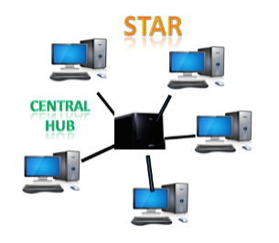

* Star topology is an arrangement of the network in which every node is connected to the central hub, switch or a central computer.
* The central computer is known as a **server**, and the peripheral devices attached to the server are known as **clients**.
* Coaxial cable or RJ-45 cables are used to connect the computers.
* Hubs or Switches are mainly used as connection devices in a **physical star topology**.
* Star topology is the most popular topology in network implementation.

### **Advantages of Star topology**

* **Efficient troubleshooting:** Troubleshooting is quite efficient in a star topology as compared to bus topology. In a bus topology, the manager has to inspect the kilometers of cable. In a star topology, all the stations are connected to the centralized network. Therefore, the network administrator has to go to the single station to troubleshoot the problem.
* **Network control:** Complex network control features can be easily implemented in the star topology. Any changes made in the star topology are automatically accommodated.
* **Limited failure:** As each station is connected to the central hub with its own cable, therefore failure in one cable will not affect the entire network.
* **Familiar technology:** Star topology is a familiar technology as its tools are cost-effective.
* **Easily expandable:** It is easily expandable as new stations can be added to the open ports on the hub.
* **Cost effective:** Star topology networks are cost-effective as it uses inexpensive coaxial cable.
* **High data speeds:** It supports a bandwidth of approx 100Mbps. Ethernet 100BaseT is one of the most popular Star topology networks.

### **Disadvantages of Star topology**

* **A Central point of failure:** If the central hub or switch goes down, then all the connected nodes will not be able to communicate with each other.
* **Cable:** Sometimes cable routing becomes difficult when a significant amount of routing is required.

## **Tree topology**

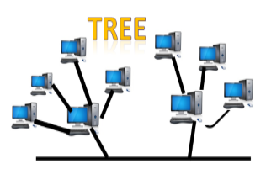

* Tree topology combines the characteristics of bus topology and star topology.
* A tree topology is a type of structure in which all the computers are connected with each other in hierarchical fashion.
* The top-most node in tree topology is known as a root node, and all other nodes are the descendants of the root node.
* There is only one path exists between two nodes for the data transmission. Thus, it forms a parent-child hierarchy.

### **Advantages of Tree topology**

* **Support for broadband transmission:** Tree topology is mainly used to provide broadband transmission, i.e., signals are sent over long distances without being attenuated.
* **Easily expandable:** We can add the new device to the existing network. Therefore, we can say that tree topology is easily expandable.
* **Easily manageable:** In tree topology, the whole network is divided into segments known as star networks which can be easily managed and maintained.
* **Error detection:** Error detection and error correction are very easy in a tree topology.
* **Limited failure:** The breakdown in one station does not affect the entire network.
* **Point-to-point wiring:** It has point-to-point wiring for individual segments.

### **Disadvantages of Tree topology**

* **Difficult troubleshooting:** If any fault occurs in the node, then it becomes difficult to troubleshoot the problem.
* **High cost:** Devices required for broadband transmission are very costly.
* **Failure:** A tree topology mainly relies on main bus cable and failure in main bus cable will damage the overall network.
* **Reconfiguration difficult:** If new devices are added, then it becomes difficult to reconfigure.

## **Mesh topology**

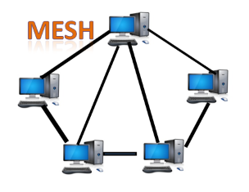

* Mesh technology is an arrangement of the network in which computers are interconnected with each other through various redundant connections.
* There are multiple paths from one computer to another computer.
* It does not contain the switch, hub or any central computer which acts as a central point of communication.
* The Internet is an example of the mesh topology.
* Mesh topology is mainly used for WAN implementations where communication failures are a critical concern.
* Mesh topology is mainly used for wireless networks.
* Mesh topology can be formed by using the formula:  
  **Number of cables = (n*(n-1))/2;**

Where n is the number of nodes that represents the network.

**Mesh topology is divided into two categories:**

* Fully connected mesh topology
* Partially connected mesh topology

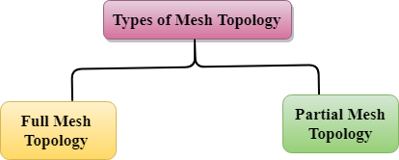

* **Full Mesh Topology:** In a full mesh topology, each computer is connected to all the computers available in the network.
* **Partial Mesh Topology:** In a partial mesh topology, not all but certain computers are connected to those computers with which they communicate frequently.

### **Advantages of Mesh topology:**

**Reliable:** The mesh topology networks are very reliable as if any link breakdown will not affect the communication between connected computers.

**Fast Communication:** Communication is very fast between the nodes.

**Easier Reconfiguration:** Adding new devices would not disrupt the communication between other devices.

### **Disadvantages of Mesh topology**

* **Cost:** A mesh topology contains a large number of connected devices such as a router and more transmission media than other topologies.
* **Management:** Mesh topology networks are very large and very difficult to maintain and manage. If the network is not monitored carefully, then the communication link failure goes undetected.
* **Efficiency:** In this topology, redundant connections are high that reduces the efficiency of the network.

## **Hybrid Topology**

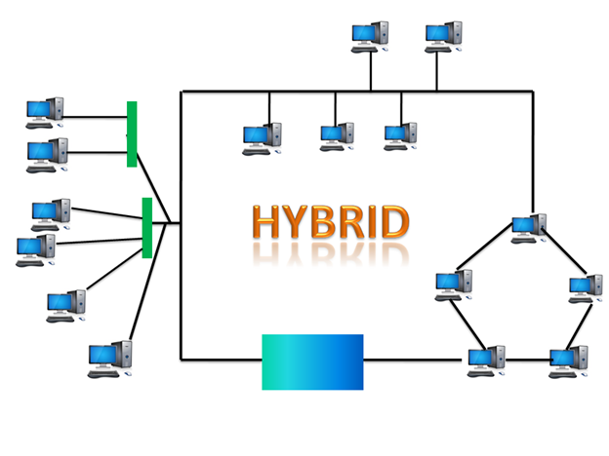

* The combination of various different topologies is known as **Hybrid topology**.
* A Hybrid topology is a connection between different links and nodes to transfer the data.
* When two or more different topologies are combined together is termed as Hybrid topology and if similar topologies are connected with each other will not result in Hybrid topology. For example, if there exist a ring topology in one branch of ICICI bank and bus topology in another branch of ICICI bank, connecting these two topologies will result in Hybrid topology.

### **Advantages of Hybrid Topology**

* **Reliable:** If a fault occurs in any part of the network will not affect the functioning of the rest of the network.
* **Scalable:** Size of the network can be easily expanded by adding new devices without affecting the functionality of the existing network.
* **Flexible:** This topology is very flexible as it can be designed according to the requirements of the organization.
* **Effective:** Hybrid topology is very effective as it can be designed in such a way that the strength of the network is maximized and weakness of the network is minimized.

### **Disadvantages of Hybrid topology**

* **Complex design:** The major drawback of the Hybrid topology is the design of the Hybrid network. It is very difficult to design the architecture of the Hybrid network.
* **Costly Hub:** The Hubs used in the Hybrid topology are very expensive as these hubs are different from usual Hubs used in other topologies.
* **Costly infrastructure:** The infrastructure cost is very high as a hybrid network requires a lot of cabling, network devices, etc.

# Transmission modes

* The way in which data is transmitted from one device to another device is known as **transmission mode**.
* The transmission mode is also known as the communication mode.
* Each communication channel has a direction associated with it, and transmission media provide the direction. Therefore, the transmission mode is also known as a directional mode.
* The transmission mode is defined in the physical layer.

The Transmission mode is divided into three categories:

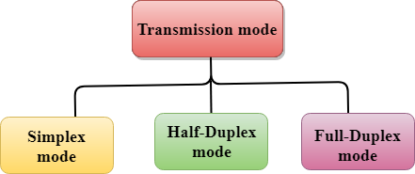

* Simplex mode
* Half-duplex mode
* Full-duplex mode

## **Simplex mode**



* In Simplex mode, the communication is unidirectional, i.e., the data flow in one direction.
* A device can only send the data but cannot receive it or it can receive the data but cannot send the data.
* This transmission mode is not very popular as mainly communications require the two-way exchange of data. The simplex mode is used in the business field as in sales that do not require any corresponding reply.
* The radio station is a simplex channel as it transmits the signal to the listeners but never allows them to transmit back.
* Keyboard and Monitor are the examples of the simplex mode as a keyboard can only accept the data from the user and monitor can only be used to display the data on the screen.
* The main advantage of the simplex mode is that the full capacity of the communication channel can be utilized during transmission.

### **Advantage of Simplex mode:**

* In simplex mode, the station can utilize the entire bandwidth of the communication channel, so that more data can be transmitted at a time.

### **Disadvantage of Simplex mode:**

* Communication is unidirectional, so it has no inter-communication between devices.

## **Half-Duplex mode**

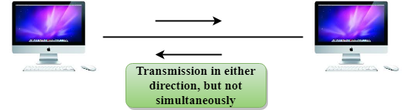

* In a Half-duplex channel, direction can be reversed, i.e., the station can transmit and receive the data as well.
* Messages flow in both the directions, but not at the same time.
* The entire bandwidth of the communication channel is utilized in one direction at a time.
* In half-duplex mode, it is possible to perform the error detection, and if any error occurs, then the receiver requests the sender to retransmit the data.
* A **Walkie-talkie** is an example of the Half-duplex mode. In Walkie-talkie, one party speaks, and another party listens. After a pause, the other speaks and first party listens. Speaking simultaneously will create the distorted sound which cannot be understood.

### **Advantage of Half-duplex mode:**

* In half-duplex mode, both the devices can send and receive the data and also can utilize the entire bandwidth of the communication channel during the transmission of data.

### **Disadvantage of Half-Duplex mode:**

* In half-duplex mode, when one device is sending the data, then another has to wait, this causes the delay in sending the data at the right time.

## **Full-duplex mode**



* In Full duplex mode, the communication is bi-directional, i.e., the data flow in both the directions.
* Both the stations can send and receive the message simultaneously.
* Full-duplex mode has two simplex channels. One channel has traffic moving in one direction, and another channel has traffic flowing in the opposite direction.
* The Full-duplex mode is the fastest mode of communication between devices.
* The most common example of the full-duplex mode is a telephone network. When two people are communicating with each other by a telephone line, both can talk and listen at the same time.

### **Advantage of Full-duplex mode:**

* Both the stations can send and receive the data at the same time.

### **Disadvantage of Full-duplex mode:**

* If there is no dedicated path exists between the devices, then the capacity of the communication channel is divided into two parts.

# OSI Model

* OSI stands for **Open System Interconnection** is a reference model that describes how information from a [software](https://www.javatpoint.com/software) application in one [computer](https://www.javatpoint.com/what-is-computer) moves through a physical medium to the software application in another computer.
* OSI consists of seven layers, and each layer performs a particular network function.
* OSI model was developed by the International Organization for Standardization (ISO) in 1984, and it is now considered as an architectural model for the inter-computer communications.
* OSI model divides the whole task into seven smaller and manageable tasks. Each layer is assigned a particular task.
* Each layer is self-contained, so that task assigned to each layer can be performed independently.

## **Characteristics of OSI Model:**

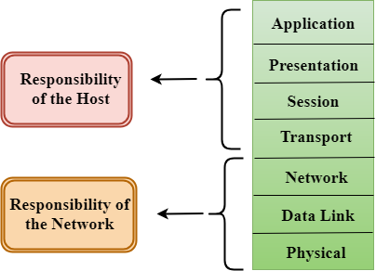

* The OSI model is divided into two layers: upper layers and lower layers.
* The upper layer of the OSI model mainly deals with the application related issues, and they are implemented only in the software. The application layer is closest to the end user. Both the end user and the application layer interact with the software applications. An upper layer refers to the layer just above another layer.
* The lower layer of the OSI model deals with the data transport issues. The data link layer and the physical layer are implemented in hardware and software. The physical layer is the lowest layer of the OSI model and is closest to the physical medium. The physical layer is mainly responsible for placing the information on the physical medium.

## **Functions of the OSI Layers**

There are the seven OSI layers. Each layer has different functions. A list of seven layers are given below:

1. Physical Layer
2. Data-Link Layer
3. Network Layer
4. Transport Layer
5. Session Layer
6. Presentation Layer
7. Application Layer

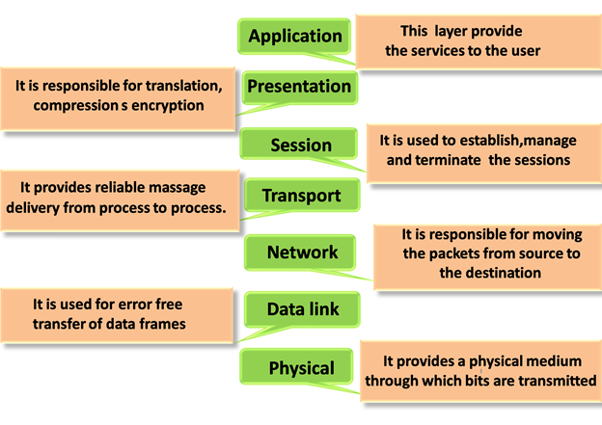

### **Physical layer**

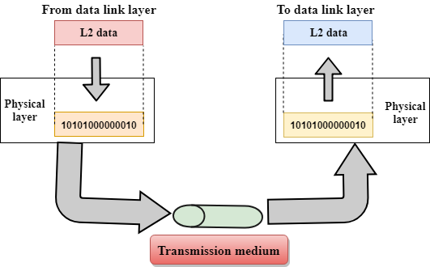

* The main functionality of the physical layer is to transmit the individual bits from one node to another node.
* It is the lowest layer of the OSI model.
* It establishes, maintains and deactivates the physical connection.
* It specifies the mechanical, electrical and procedural network interface specifications.

## **Functions of a Physical layer:**

* **Line Configuration:** It defines the way how two or more devices can be connected physically.
* [**Data Transmission**](https://www.javatpoint.com/computer-network-transmission-modes)**:** It defines the transmission mode whether it is simplex, half-duplex or full-duplex mode between the two devices on the network.
* [**Topology**](https://www.javatpoint.com/computer-network-topologies)**:** It defines the way how network devices are arranged.
* **Signals:** It determines the type of the signal used for transmitting the information.

### **Data-Link Layer**

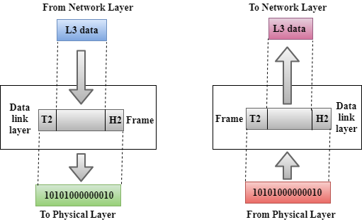

* This layer is responsible for the error-free transfer of data frames.
* It defines the format of the data on the network.
* It provides a reliable and efficient communication between two or more devices.
* It is mainly responsible for the unique identification of each device that resides on a local network.
* It contains two sub-layers:
  + **Logical Link Control Layer**
    - It is responsible for transferring the packets to the Network layer of the receiver that is receiving.
    - It identifies the address of the network layer protocol from the header.
    - It also provides flow control.
  + **Media Access Control Layer**
    - A Media access control layer is a link between the Logical Link Control layer and the network's physical layer.
    - It is used for transferring the packets over the network.

## **Functions of the Data-link layer**

* **Framing:** The data link layer translates the physical's raw bit stream into packets known as Frames. The Data link layer adds the header and trailer to the frame. The header which is added to the frame contains the hardware destination and source address.

OSI Model

* **Physical Addressing:** The Data link layer adds a header to the frame that contains a destination address. The frame is transmitted to the destination address mentioned in the header.
* **Flow Control:** Flow control is the main functionality of the Data-link layer. It is the technique through which the constant data rate is maintained on both the sides so that no data get corrupted. It ensures that the transmitting station such as a server with higher processing speed does not exceed the receiving station, with lower processing speed.
* **Error Control:** Error control is achieved by adding a calculated value CRC (Cyclic Redundancy Check) that is placed to the Data link layer's trailer which is added to the message frame before it is sent to the physical layer. If any error seems to occurr, then the receiver sends the acknowledgment for the retransmission of the corrupted frames.
* **Access Control:** When two or more devices are connected to the same communication channel, then the data link layer protocols are used to determine which device has control over the link at a given time.

### **Network Layer**

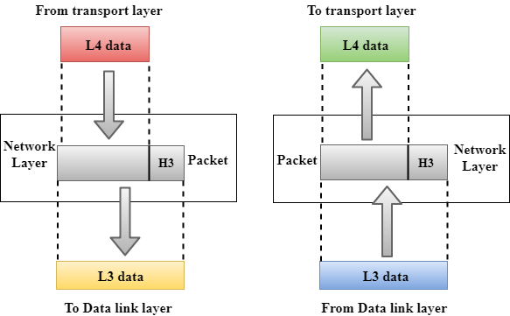

* It is a layer 3 that manages device addressing, tracks the location of devices on the network.
* It determines the best path to move data from source to the destination based on the network conditions, the priority of service, and other factors.
* The Data link layer is responsible for routing and forwarding the packets.
* Routers are the layer 3 devices, they are specified in this layer and used to provide the routing services within an internetwork.
* The protocols used to route the network traffic are known as Network layer protocols. Examples of protocols are IP and Ipv6.

## **Functions of Network Layer:**

* **Internetworking:** An internetworking is the main responsibility of the network layer. It provides a logical connection between different devices.
* [**Addressing**](https://www.javatpoint.com/network-addressing)**:** A Network layer adds the source and destination address to the header of the frame. Addressing is used to identify the device on the internet.
* [**Routing**](https://www.javatpoint.com/computer-network-routing)**:** Routing is the major component of the network layer, and it determines the best optimal path out of the multiple paths from source to the destination.
* **Packetizing:** A Network Layer receives the packets from the upper layer and converts them into packets. This process is known as Packetizing. It is achieved by internet protocol (IP).

### **Transport Layer**

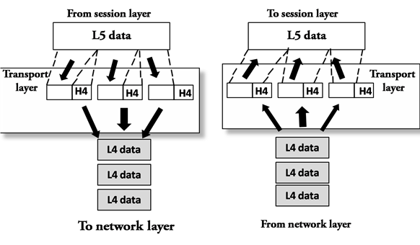

* The Transport layer is a Layer 4 ensures that messages are transmitted in the order in which they are sent and there is no duplication of data.
* The main responsibility of the transport layer is to transfer the data completely.
* It receives the data from the upper layer and converts them into smaller units known as segments.
* This layer can be termed as an end-to-end layer as it provides a point-to-point connection between source and destination to deliver the data reliably.

**The two protocols used in this layer are:**

* **Transmission Control Protocol**
  + It is a standard protocol that allows the systems to communicate over the internet.
  + It establishes and maintains a connection between hosts.
  + When data is sent over the TCP connection, then the TCP protocol divides the data into smaller units known as segments. Each segment travels over the internet using multiple routes, and they arrive in different orders at the destination. The transmission control protocol reorders the packets in the correct order at the receiving end.
* **User Datagram Protocol**
  + User Datagram Protocol is a transport layer protocol.
  + It is an unreliable transport protocol as in this case receiver does not send any acknowledgment when the packet is received, the sender does not wait for any acknowledgment. Therefore, this makes a protocol unreliable.

## **Functions of Transport Layer:**

* **Service-point addressing:** Computers run several programs simultaneously due to this reason, the transmission of data from source to the destination not only from one computer to another computer but also from one process to another process. The transport layer adds the header that contains the address known as a service-point address or port address. The responsibility of the network layer is to transmit the data from one computer to another computer and the responsibility of the transport layer is to transmit the message to the correct process.
* **Segmentation and reassembly:** When the transport layer receives the message from the upper layer, it divides the message into multiple segments, and each segment is assigned with a sequence number that uniquely identifies each segment. When the message has arrived at the destination, then the transport layer reassembles the message based on their sequence numbers.
* **Connection control:** Transport layer provides two services Connection-oriented service and connectionless service. A connectionless service treats each segment as an individual packet, and they all travel in different routes to reach the destination. A connection-oriented service makes a connection with the transport layer at the destination machine before delivering the packets. In connection-oriented service, all the packets travel in the single route.
* **Flow control:** The transport layer also responsible for flow control but it is performed end-to-end rather than across a single link.
* **Error control:** The transport layer is also responsible for Error control. Error control is performed end-to-end rather than across the single link. The sender transport layer ensures that message reach at the destination without any error.

### **Session Layer**

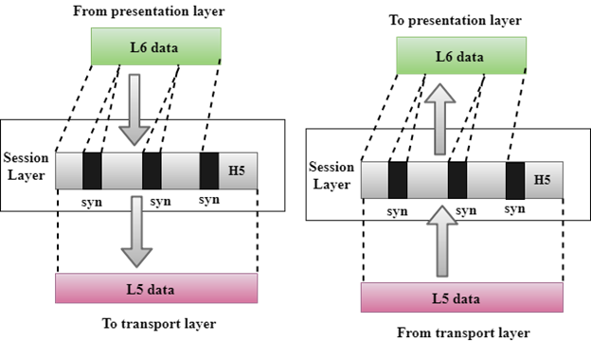

* It is a layer 3 in the OSI model.
* The Session layer is used to establish, maintain and synchronizes the interaction between communicating devices.

## **Functions of Session layer:**

* **Dialog control:** Session layer acts as a dialog controller that creates a dialog between two processes or we can say that it allows the communication between two processes which can be either half-duplex or full-duplex.
* **Synchronization:** Session layer adds some checkpoints when transmitting the data in a sequence. If some error occurs in the middle of the transmission of data, then the transmission will take place again from the checkpoint. This process is known as Synchronization and recovery.

### **Presentation Layer**

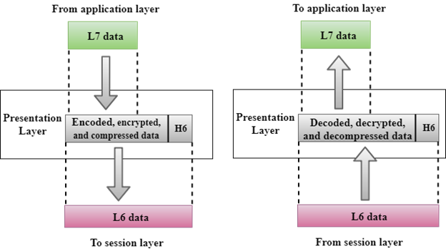

* A Presentation layer is mainly concerned with the syntax and semantics of the information exchanged between the two systems.
* It acts as a data translator for a network.
* This layer is a part of the operating system that converts the data from one presentation format to another format.
* The Presentation layer is also known as the syntax layer.

## **Functions of Presentation layer:**

* **Translation:** The processes in two systems exchange the information in the form of character strings, numbers and so on. Different computers use different encoding methods, the presentation layer handles the interoperability between the different encoding methods. It converts the data from sender-dependent format into a common format and changes the common format into receiver-dependent format at the receiving end.
* **Encryption:** Encryption is needed to maintain privacy. Encryption is a process of converting the sender-transmitted information into another form and sends the resulting message over the network.
* **Compression:** Data compression is a process of compressing the data, i.e., it reduces the number of bits to be transmitted. Data compression is very important in multimedia such as text, audio, video.

### **Application Layer**

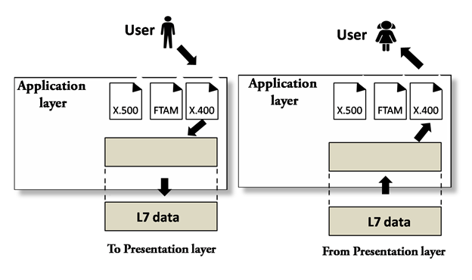

* An application layer serves as a window for users and application processes to access network service.
* It handles issues such as network transparency, resource allocation, etc.
* An application layer is not an application, but it performs the application layer functions.
* This layer provides the network services to the end-users.

## **Functions of Application layer:**

* **File transfer, access, and management (FTAM):** An application layer allows a user to access the files in a remote computer, to retrieve the files from a computer and to manage the files in a remote computer.
* **Mail services:** An application layer provides the facility for email forwarding and storage.
* Directory services: An application provides the distributed database sources and is used to provide that global information about various objects.

# TCP/IP model

* The TCP/IP model was developed prior to the OSI model.
* The TCP/IP model is not exactly similar to the OSI model.
* The TCP/IP model consists of five layers: the application layer, transport layer, network layer, data link layer and physical layer.
* The first four layers provide physical standards, network interface, internetworking, and transport functions that correspond to the first four layers of the OSI model and these four layers are represented in TCP/IP model by a single layer called the application layer.
* TCP/IP is a hierarchical protocol made up of interactive modules, and each of them provides specific functionality.

Here, hierarchical means that each upper-layer protocol is supported by two or more lower-level protocols.

## **Functions of TCP/IP layers:**

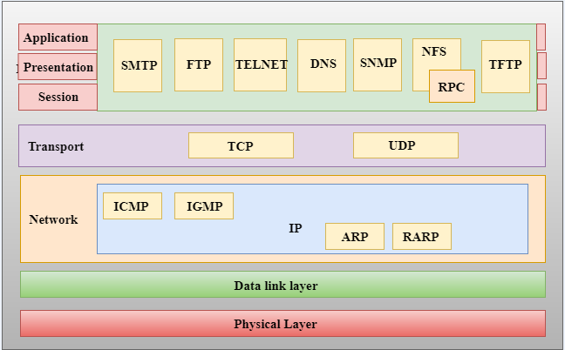

## **Network Access Layer**

* A network layer is the lowest layer of the TCP/IP model.
* A network layer is the combination of the Physical layer and Data Link layer defined in the OSI reference model.
* It defines how the data should be sent physically through the network.
* This layer is mainly responsible for the transmission of the data between two devices on the same network.
* The functions carried out by this layer are encapsulating the IP datagram into frames transmitted by the network and mapping of IP addresses into physical addresses.
* The protocols used by this layer are ethernet, token ring, FDDI, X.25, frame relay.

## **Internet Layer**

* An internet layer is the second layer of the TCP/IP model.
* An internet layer is also known as the network layer.
* The main responsibility of the internet layer is to send the packets from any network, and they arrive at the destination irrespective of the route they take.

### **Following are the protocols used in this layer are:**

**IP Protocol:** IP protocol is used in this layer, and it is the most significant part of the entire TCP/IP suite.

Following are the responsibilities of this protocol:

* **IP Addressing:** This protocol implements logical host addresses known as IP addresses. The IP addresses are used by the internet and higher layers to identify the device and to provide internetwork routing.
* **Host-to-host communication:** It determines the path through which the data is to be transmitted.
* **Data Encapsulation and Formatting:** An IP protocol accepts the data from the transport layer protocol. An IP protocol ensures that the data is sent and received securely, it encapsulates the data into message known as IP datagram.
* **Fragmentation and Reassembly:** The limit imposed on the size of the IP datagram by data link layer protocol is known as Maximum Transmission unit (MTU). If the size of IP datagram is greater than the MTU unit, then the IP protocol splits the datagram into smaller units so that they can travel over the local network. Fragmentation can be done by the sender or intermediate router. At the receiver side, all the fragments are reassembled to form an original message.
* **Routing:** When IP datagram is sent over the same local network such as LAN, MAN, WAN, it is known as direct delivery. When source and destination are on the distant network, then the IP datagram is sent indirectly. This can be accomplished by routing the IP datagram through various devices such as routers.

**ARP Protocol**

* ARP stands for **Address Resolution Protocol**.
* ARP is a network layer protocol which is used to find the physical address from the IP address.
* **The two terms are mainly associated with the ARP Protocol:**
  + **ARP request:** When a sender wants to know the physical address of the device, it broadcasts the ARP request to the network.
  + **ARP reply:** Every device attached to the network will accept the ARP request and process the request, but only recipient recognize the IP address and sends back its physical address in the form of ARP reply. The recipient adds the physical address both to its cache memory and to the datagram header

**ICMP Protocol**

* **ICMP** stands for Internet Control Message Protocol.
* It is a mechanism used by the hosts or routers to send notifications regarding datagram problems back to the sender.
* A datagram travels from router-to-router until it reaches its destination. If a router is unable to route the data because of some unusual conditions such as disabled links, a device is on fire or network congestion, then the ICMP protocol is used to inform the sender that the datagram is undeliverable.
* An ICMP protocol mainly uses two terms:
  + **ICMP Test:** ICMP Test is used to test whether the destination is reachable or not.
  + **ICMP Reply:** ICMP Reply is used to check whether the destination device is responding or not.
* The core responsibility of the ICMP protocol is to report the problems, not correct them. The responsibility of the correction lies with the sender.
* ICMP can send the messages only to the source, but not to the intermediate routers because the IP datagram carries the addresses of the source and destination but not of the router that it is passed to.

## **Transport Layer**

The transport layer is responsible for the reliability, flow control, and correction of data which is being sent over the network.

The two protocols used in the transport layer are **User Datagram protocol and Transmission control protocol**.

* **User Datagram Protocol (UDP)**
  + It provides connectionless service and end-to-end delivery of transmission.
  + It is an unreliable protocol as it discovers the errors but not specify the error.
  + User Datagram Protocol discovers the error, and ICMP protocol reports the error to the sender that user datagram has been damaged.
  + **UDP consists of the following fields:**  
    **Source port address:** The source port address is the address of the application program that has created the message.  
    **Destination port address:** The destination port address is the address of the application program that receives the message.  
    **Total length:** It defines the total number of bytes of the user datagram in bytes.  
    **Checksum:** The checksum is a 16-bit field used in error detection.
  + UDP does not specify which packet is lost. UDP contains only checksum; it does not contain any ID of a data segment.

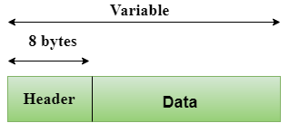  
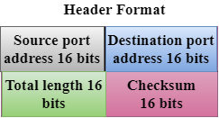

* **Transmission Control Protocol (TCP)**
  + It provides a full transport layer services to applications.
  + It creates a virtual circuit between the sender and receiver, and it is active for the duration of the transmission.
  + TCP is a reliable protocol as it detects the error and retransmits the damaged frames. Therefore, it ensures all the segments must be received and acknowledged before the transmission is considered to be completed and a virtual circuit is discarded.
  + At the sending end, TCP divides the whole message into smaller units known as segment, and each segment contains a sequence number which is required for reordering the frames to form an original message.
  + At the receiving end, TCP collects all the segments and reorders them based on sequence numbers.

## **Application Layer**

* An application layer is the topmost layer in the TCP/IP model.
* It is responsible for handling high-level protocols, issues of representation.
* This layer allows the user to interact with the application.
* When one application layer protocol wants to communicate with another application layer, it forwards its data to the transport layer.
* There is an ambiguity occurs in the application layer. Every application cannot be placed inside the application layer except those who interact with the communication system. For example: text editor cannot be considered in application layer while web browser using **HTTP** protocol to interact with the network where **HTTP** protocol is an application layer protocol.

### **Following are the main protocols used in the application layer:**

* **HTTP:** HTTP stands for Hypertext transfer protocol. This protocol allows us to access the data over the world wide web. It transfers the data in the form of plain text, audio, video. It is known as a Hypertext transfer protocol as it has the efficiency to use in a hypertext environment where there are rapid jumps from one document to another.
* **SNMP:** SNMP stands for Simple Network Management Protocol. It is a framework used for managing the devices on the internet by using the TCP/IP protocol suite.
* **SMTP:** SMTP stands for Simple mail transfer protocol. The TCP/IP protocol that supports the e-mail is known as a Simple mail transfer protocol. This protocol is used to send the data to another e-mail address.
* **DNS:** DNS stands for Domain Name System. An IP address is used to identify the connection of a host to the internet uniquely. But, people prefer to use the names instead of addresses. Therefore, the system that maps the name to the address is known as Domain Name System.
* **TELNET:** It is an abbreviation for Terminal Network. It establishes the connection between the local computer and remote computer in such a way that the local terminal appears to be a terminal at the remote system.
* **FTP:** FTP stands for File Transfer Protocol. FTP is a standard internet protocol used for transmitting the files from one computer to another computer

# Data and Signals in Physical layer

BY CHAITANYA SINGH | FILED UNDER: [**COMPUTER NETWORK**](https://beginnersbook.com/category/computer-network/)

One of the major role of **Physical layer** is to transfer the **data in form of signals** through a transmission medium. It doesn’t matter what data you are sending, it can be text, audio, image, video etc. everything is transferred in form of signals. This happens because a data cannot be send as it is over a transmission medium, it must be converted to a form that is acceptable by the transmission media, signals are what a transmission medium carry. In this guide, we will discuss data and signals.

## Analog and Digital

Both the data and the signal can be represented in form of analog and digital.

**Analog and Digital Data:**  
Analog data is continuous data that keeps changing over time, for example in an analog watch, the hour, minute and second hands keep moving so you infer the time by looking at it, it keeps changing. On the other hand digital watch shows you discrete data such as 12:20 AM, 5:30 PM etc. at a particular moment of time.

**Analog and Digital Signals:**  
Similar to data, a signal can be analog or digital. An analog signal can have infinite number of values in a given range, on the other hand a digital signal has limited number of values in a given range. The following digram shows analog and digital signals.

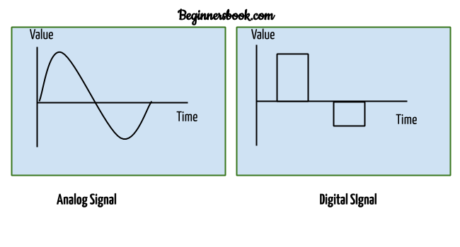

## 1. Analog Signals

An analog signal can be be categorized as **simple** or **composite**.

### 1.1 Simple Analog signal

A simple analog signal can be represented in form of sine wave. A sine wave is shown in the above diagram.

A simple analog signal is smooth, consistent and continuous. As you can see in the diagram above that a arc above the time axis is followed by the similar arc below the time axis and so on.

#### Parameters of simple Analog signal – Sine wave

There are three parameters that defines a sine wave – peak amplitude, frequency and phase.

**Peak amplitude**: Absolute value of highest intensity of sine wave.

**Frequency and Period**: Period is the amount of time a signal takes to complete one cycle, it is denoted by T. Frequency refers to the number of cycles in 1 second, it is denoted by f. They are inversely proportional to each other which means f = 1/T.

**Phase**: Phase refers to the position of sine wave relative to the time 0. For example if the sine wave is at its highest intensity at the time zero then the phase value for this sine wave is 90 degrees. Phase is measured in degrees or radians.

### 1.2 Composite Analog signal

Unlike sine wave which is smooth and consistent, composite analog signals or waves are not smooth and consistent, which means an arc above the time axis doesn’t necessarily followed by arc below the time axis. You can imagine them as a group of sine waves with different frequency, amplitude and period.

**Bandwidth:** The range of frequencies in a composite signal is called bandwidth. For example if a composite signal contains waves with the frequencies ranging from 2000 to 4000 then you can say that the bandwidth of this composite signal is 4000-2000 = 2000Hz. Bandwidth is measured in Hz.

## 2. Digital Signals

Similar to analog signals, data can be transmitted in form of digital signals. For example a data that is converted it into a machine language (combination of 0s and 1s) such as 1001 can be represented in form digital signals. 1 represents high voltage and 0 represents low voltage.

**Bit Rate:** A bit rate is measured as bits per second, it represents the number of 1s send in 1 second.

**Bit Length:** A bit length is the distance a bit occupies on the transmission medium.

# Digital Transmission

Data can be represented either in analog or digital form. The computers used the digital form to store the information. Therefore, the data needs to be converted in digital form so that it can be used by a computer.

## **DIGITAL-TO-DIGITAL CONVERSION**

Digital-to-digital encoding is the representation of digital information by a digital signal. When binary 1s and 0s generated by the computer are translated into a sequence of voltage pulses that can be propagated over a wire, this process is known as digital-to-digital encoding.

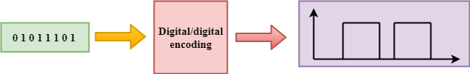

Digital-to-digital encoding is divided into three categories:

* Unipolar Encoding
* Polar Encoding
* Bipolar Encoding

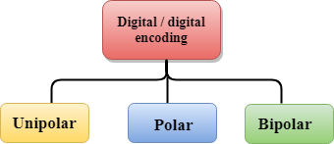

## **Unipolar**

* Digital transmission system sends the voltage pulses over the medium link such as wire or cable.
* In most types of encoding, one voltage level represents 0, and another voltage level represents 1.
* The polarity of each pulse determines whether it is positive or negative.
* This type of encoding is known as Unipolar encoding as it uses only one polarity.
* In Unipolar encoding, the polarity is assigned to the 1 binary state.
* In this, 1s are represented as a positive value and 0s are represented as a zero value.
* In Unipolar Encoding, '1' is considered as a high voltage and '0' is considered as a zero voltage.
* Unipolar encoding is simpler and inexpensive to implement.

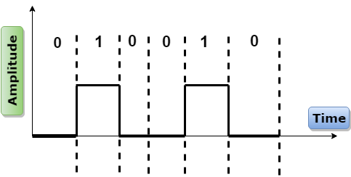

Unipolar encoding has two problems that make this scheme less desirable:

22.9M

502

C++ vs Java

* DC Component
* Synchronization

## **Polar**

* Polar encoding is an encoding scheme that uses two voltage levels: one is positive, and another is negative.
* By using two voltage levels, an average voltage level is reduced, and the DC component problem of unipolar encoding scheme is alleviated.

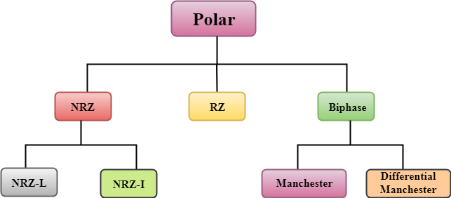

### **NRZ**

* NRZ stands for Non-return zero.
* In NRZ encoding, the level of the signal can be represented either positive or negative.

**The two most common methods used in NRZ are:**

**NRZ-L:** In NRZ-L encoding, the level of the signal depends on the type of the bit that it represents. If a bit is 0 or 1, then their voltages will be positive and negative respectively. Therefore, we can say that the level of the signal is dependent on the state of the bit.

**NRZ-I:** NRZ-I is an inversion of the voltage level that represents 1 bit. In the NRZ-I encoding scheme, a transition occurs between the positive and negative voltage that represents 1 bit. In this scheme, 0 bit represents no change and 1 bit represents a change in voltage level.

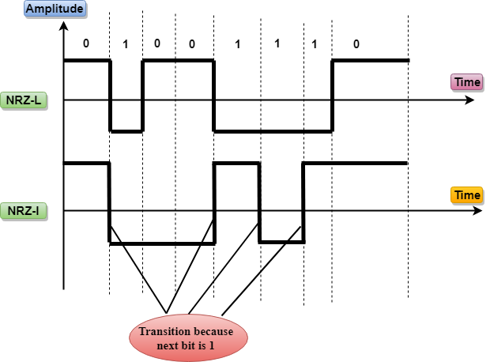

### **RZ**

* RZ stands for Return to zero.
* There must be a signal change for each bit to achieve synchronization. However, to change with every bit, we need to have three values: positive, negative and zero.
* RZ is an encoding scheme that provides three values, positive voltage represents 1, the negative voltage represents 0, and zero voltage represents none.
* In the RZ scheme, halfway through each interval, the signal returns to zero.
* In RZ scheme, 1 bit is represented by positive-to-zero and 0 bit is represented by negative-to-zero.

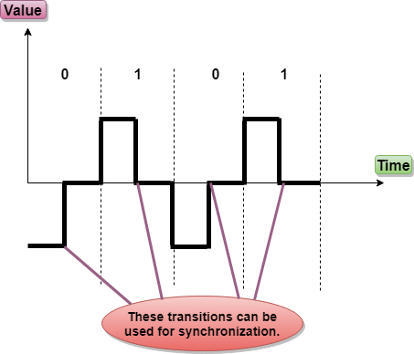

**Disadvantage of RZ:**

It performs two signal changes to encode one bit that acquires more bandwidth.

### **Biphase**

* Biphase is an encoding scheme in which signal changes at the middle of the bit interval but does not return to zero.

Biphase encoding is implemented in two different ways:

**Manchester**

* It changes the signal at the middle of the bit interval but does not return to zero for synchronization.
* In Manchester encoding, a negative-to-positive transition represents binary 1, and positive-to-negative transition represents 0.
* Manchester has the same level of synchronization as RZ scheme except that it has two levels of amplitude.

**Differential Manchester**

* It changes the signal at the middle of the bit interval for synchronization, but the presence or absence of the transition at the beginning of the interval determines the bit. A transition means binary 0 and no transition means binary 1.
* In Manchester Encoding scheme, two signal changes represent 0 and one signal change represent 1.

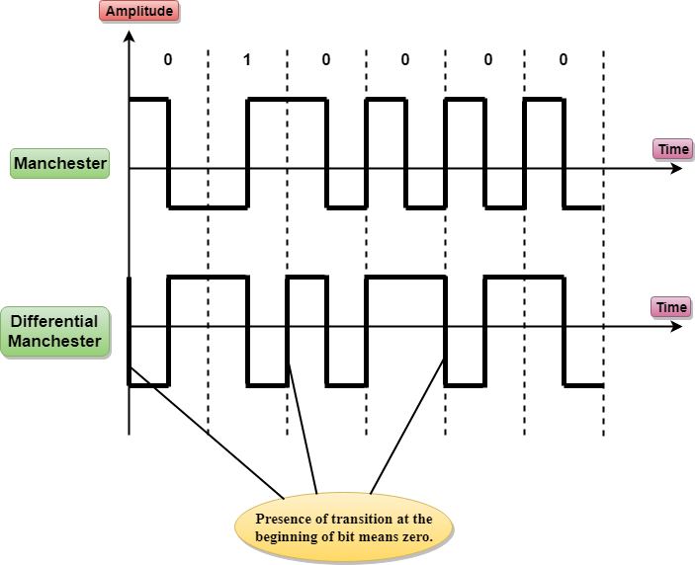

## **Bipolar**

* Bipolar encoding scheme represents three voltage levels: positive, negative, and zero.
* In Bipolar encoding scheme, zero level represents binary 0, and binary 1 is represented by alternating positive and negative voltages.
* If the first 1 bit is represented by positive amplitude, then the second 1 bit is represented by negative voltage, third 1 bit is represented by the positive amplitude and so on. This alternation can also occur even when the 1bits are not consecutive.

**Bipolar can be classified as:**

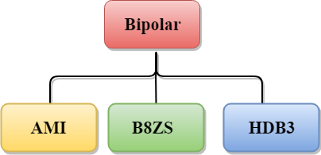

### **AMI**

* AMI stands for **alternate mark inversion** where mark work comes from telegraphy which means 1. So, it can be redefined as **alternate 1 inversion**.
* In Bipolar AMI encoding scheme, 0 bit is represented by zero level and 1 bit is represented by alternating positive and negative voltages.

**Advantage:**

* DC component is zero.
* Sequence of 1s bits are synchronized.

**Disadvantage:**

* This encoding scheme does not ensure the synchronization of a long string of 0s bits.

### **B8ZS**

* B8ZS stands for **Bipolar 8-Zero Substitution**.
* This technique is adopted in North America to provide synchronization of a long sequence of 0s bits.
* In most of the cases, the functionality of B8ZS is similar to the bipolar AMI, but the only difference is that it provides the synchronization when a long sequence of 0s bits occur.
* B8ZS ensures synchronization of a long string of 0s by providing force artificial signal changes called violations, within 0 string pattern.
* When eight 0 occurs, then B8ZS implements some changes in 0s string pattern based on the polarity of the previous 1 bit.
* If the polarity of the previous 1 bit is positive, the eight 0s will be encoded as zero, zero, zero, positive, negative, zero, negative, positive.

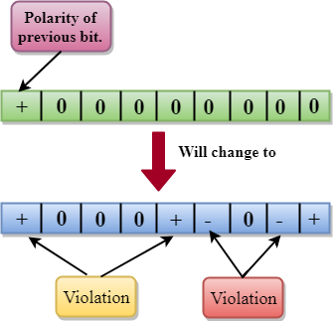

* If the polarity of previous 1 bit is negative, then the eight 0s will be encoded as zero, zero, zero, negative, positive, zero, positive, negative.

### **HDB3**

* HDB3 stands for **High-Density Bipolar 3**.
* HDB3 technique was first adopted in Europe and Japan.
* HDB3 technique is designed to provide the synchronization of a long sequence of 0s bits.
* In the HDB3 technique, the pattern of violation is based on the polarity of the previous bit.
* When four 0s occur, HDB3 looks at the number of 1s bits occurred since the last substitution.
* If the number of 1s bits is odd, then the violation is made on the fourth consecutive of 0. If the polarity of the previous bit is positive, then the violation is positive. If the polarity of the previous bit is negative, then the violation is negative.

**If the number of 1s bits since the last substitution is odd.**

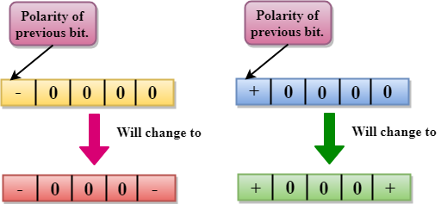

If the number of 1s bits is even, then the violation is made on the place of the first and fourth consecutive 0s. If the polarity of the previous bit is positive, then violations are negative, and if the polarity of the previous bit is negative, then violations are positive.

**If the number of 1s bits since the last substitution is even.**

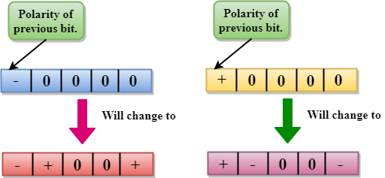

## **ANALOG-TO-DIGITAL CONVERSION**

* When an analog signal is digitalized, this is called an analog-to-digital conversion.
* Suppose human sends a voice in the form of an analog signal, we need to digitalize the analog signal which is less prone to noise. It requires a reduction in the number of values in an analog message so that they can be represented in the digital stream.
* In analog-to-digital conversion, the information contained in a continuous wave form is converted in digital pulses.

### **Techniques for Analog-To-Digital Conversion**

### **PAM**

* PAM stands for **pulse amplitude modulation**.
* PAM is a technique used in analog-to-digital conversion.
* PAM technique takes an analog signal, samples it, and generates a series of digital pulses based on the result of sampling where sampling means measuring the amplitude of a signal at equal intervals.
* PAM technique is not useful in data communication as it translates the original wave form into pulses, but these pulses are not digital. To make them digital, PAM technique is modified to PCM technique.

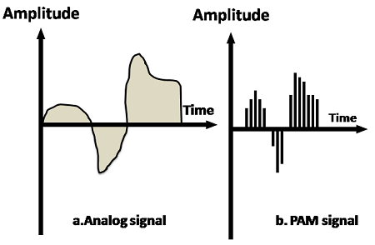  
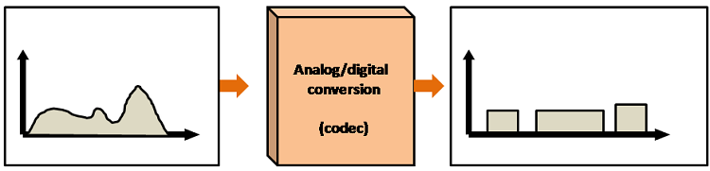

### **PCM**

* PCM stands for **Pulse Code Modulation**.
* PCM technique is used to modify the pulses created by PAM to form a digital signal. To achieve this, PCM quantizes PAM pulses. Quantization is a process of assigning integral values in a specific range to sampled instances.
* PCM is made of four separate processes: PAM, quantization, binary encoding, and digital-to-digital encoding.

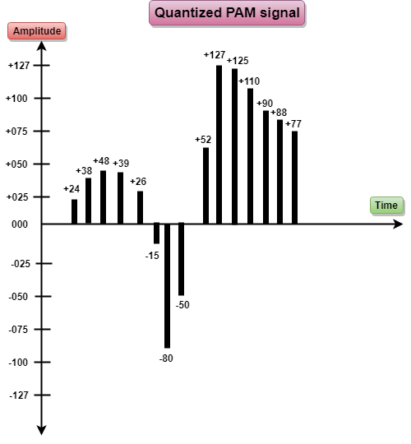

**PCM**

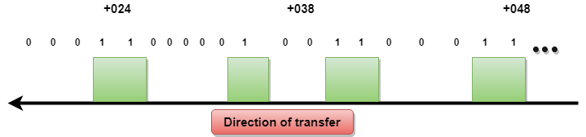

**igital to Analog Conversion**

* Difficulty Level : [Easy](https://www.geeksforgeeks.org/easy/)
* Last Updated : 25 Nov, 2019

**Digital Signal –** A digital signal is a signal that represents data as a sequence of discrete values; at any given time it can only take on one of a finite number of values.

**Analog Signal –**An analog signal is any continuous signal for which the time varying feature of the signal is a representation of some other time varying quantity i.e., analogous to another time varying signal.

Attention reader! Don’t stop learning now. Get hold of all the important CS Theory concepts for SDE interviews with the [**CS Theory Course**](https://practice.geeksforgeeks.org/courses/SDE-theory?vC=1) at a student-friendly price and become industry ready.

The following techniques can be used for Digital to Analog Conversion:

**1. Amplitude Shift keying –** Amplitude Shift Keying is a technique in which carrier signal is analog and data to be modulated is digital. The amplitude of analog carrier signal is modified to reflect binary data.

The binary signal when modulated gives a zero value when the binary data represents 0 while gives the carrier output when data is 1. The frequency and phase of the carrier signal remain constant.  
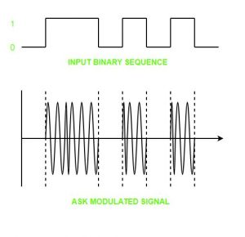

**Advantages of amplitude shift Keying –**

* It can be used to transmit digital data over optical fiber.
* The receiver and transmitter have a simple design which also makes it comparatively inexpensive.
* It uses lesser bandwidth as compared to FSK thus it offers high bandwidth efficiency.

**Disadvantages of amplitude shift Keying –**

* It is susceptible to noise interference and entire transmissions could be lost due to this.
* It has lower power efficiency.

**2. Frequency Shift keying –**In this modulation the frequency of analog carrier signal is modified to reflect binary data.

The output of a frequency shift keying modulated wave is high in frequency for a binary high input and is low in frequency for a binary low input. The amplitude and phase of the carrier signal remain constant.  
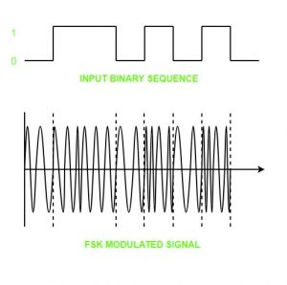

**Advantages of frequency shift Keying –**

* Frequency shift keying modulated signal can help avoid the noise problems beset by ASK.
* It has lower chances of an error.
* It provides high signal to noise ratio.
* The transmitter and receiver implementations are simple for low data rate application.

**Disadvantages of frequency shift Keying –**

* It uses larger bandwidth as compared to ASK thus it offers less bandwidth efficiency.
* It has lower power efficiency.

**3. Phase Shift keying –**In this modulation the phase of the analog carrier signal is modified to reflect binary data.The amplitude and frequency of the carrier signal remains constant.

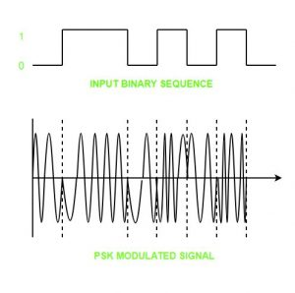

It is further categorized as follows:

1. **Binary Phase Shift Keying (BPSK):**  
   BPSK also known as phase reversal keying or 2PSK is the simplest form of phase shift keying. The Phase of the carrier wave is changed according to the two binary inputs. In Binary Phase shift keying, difference of 180 phase shift is used between binary 1 and binary 0.

This is regarded as the most robust digital modulation technique and is used for long distance wireless communication.

1. **Quadrature phase shift keying:**  
   This technique is used to increase the bit rate i.e we can code two bits onto one single element. It uses four phases to encode two bits per symbol. QPSK uses phase shifts of multiples of 90 degrees.

It has double data rate carrying capacity compare to BPSK as two bits are mapped on each constellation points.

**Advantages of phase shift Keying –**

* It is a more power efficient modulation technique as compared to ASK and FSK.
* It has lower chances of an error.
* It allows data to be carried along a communication signal much more efficiently as compared to FSK.

**Disadvantages of phase shift Keying –**

* It offers low bandwidth efficiency.
* The detection and recovery algorithms of binary data is very complex.
* It is a non coherent reference signal.